6. WebApi_Handson

1. **Create a Chat Application which uses Kafka as a streaming platform and consume the chat messages in the command prompt.**

Zookeeper running

Kafka server running

Topic created



Publisher platform

Client platform

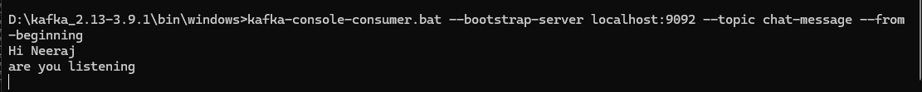

1. **Create a Chat Application using C# Windows Application using Kafka and consume the message in different client applications.**

|  |
| --- |
| namespace Kafka_DotNet  {  public partial class Form1 : Form  {  private IProducer<Null, string> _producer;  private string _kafkaTopic = "chat-message";  private string _kafkaBroker = "localhost:9092";  public Form1()  {  InitializeComponent();  this.FormClosing += new FormClosingEventHandler(Form1_FormClosing);  }  private void Form1_Load(object sender, EventArgs e)  {  var producerConfig = new ProducerConfig { BootstrapServers = _kafkaBroker };  _producer = new ProducerBuilder<Null, string>(producerConfig).Build();  }  private void Send_Click(object sender, EventArgs e)  {  string messageText = textBox1.Text.Trim();  if (string.IsNullOrEmpty(messageText))  {  MessageBox.Show("Please Enter a Message", "Warning", MessageBoxButtons.OK, MessageBoxIcon.Warning);  return;  }  _producer.Produce(_kafkaTopic, new Message<Null, string> { Value = messageText },  deliveryReport =>  {  if (deliveryReport.Error.Code != ErrorCode.NoError)  {  Console.WriteLine($"Failed to deliver message: {deliveryReport.Error.Reason}");  }  else  {  Console.WriteLine($"Delivered message to: {deliveryReport.TopicPartitionOffset}");  }  });  textBox1.Clear();  textBox1.Focus();  }  private void Form1_FormClosing(object sender, FormClosingEventArgs e)  {  _producer?.Dispose();  }  private void Cancel_Click(object sender, EventArgs e)  {  textBox1.Clear();  textBox1.Focus();  }  }  } |

